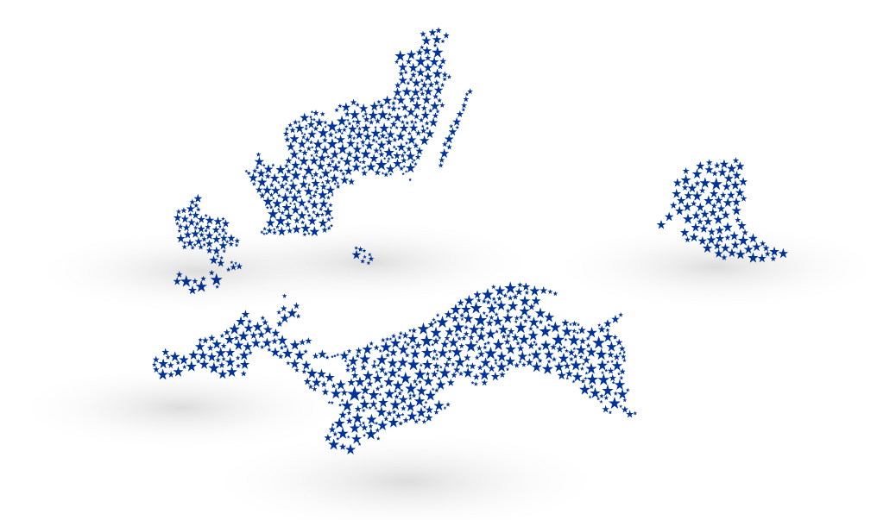

Communication Training for
Project Communication Managers

Interreg South Baltic Programme

November-December 2018, Gdańsk

- Purpose of the training

The South Baltic Programme organizes a training event for project communication managers. The training sessions will be held in English. The scope of the training will include topics such as storytelling - clear writing in stories, communication with the media, understanding the social media statistics for reaching communication objectives, sharing the examples of project communication activities.
External and internal experts on communication and public relations will lead the training sessions. An external expert should have a unique experience providing communication trainings. An external expert will share the general principles of the storytelling, how to write a good story and how to pitch a story to the media.
Expert from the digital marketing company will share how to measure communication objectives in social media (e.g. Facebook) and Google for non profit organizations.
Sharing internal experience among projects is also an important part. A few project communication managers will speak about the communication activities implemented by their projects.
It is expected to gather around 45 - 60 participants in the training sessions.
- Description of trainings

Training topic | Description
Writing persuasive stories for websites/ blogs/social media. How to use simple language to write and talk about complicated issues? | General principles of the story telling:  What is the subject of the story?  Who are the protagonists?  What sides do they represent?  How to mix verified facts and stories with a human angle to get a good story?  How to write and present a good story  The company will offer additionally small group coaching sessions covering practical exercise – to write a story on the project
Communication with media: how to pitch a story to the media? | Projects sponsored by the EU might appear boring, useful only to the local community based in peripheral provinces as the cross border cooperation programmes function in outer areas of countries.  Participants will learn how to attract the media with an interesting story covering these questions:  - what makes a good story  - how to construct that it would be attractive and appealing  - find the right media for projects and adapt the angle to suit the audience  - how to use Twitter, Facebook, e-mail, phone call effectively and attract the journalist with the idea/story  - arising problems presenting the story and how to deal with them
Google/ Facebook Analytics: measuring communication objectives | - how non-profit organisation is visible on Facebook with/without paid ads, the content.  - Facebook Analytics: measuring communication objectives  -why Google Analytics is needed for a non profit organization?  - discover how people find your site and how they interact with it
Training by project communication managers. Sharing experience.  (optional and only in case of a 2 day training session; moderated by the external company) | Exchanging communication activity experience:  - how to run a hachathon communication campaign, BalticMuseums: LoveIT.  - inspiration for creating a project website and a video, Johann.  - inspiration for publishing magazine, South Coast Baltic (TBC).  - reaching the audience interested in environmental issues, InnoAqquaTech.  - how to promote cruise for youngsters, Baltic Pass (TBC)

